Paper title (in Bulgarian) – Times New Roman, bold, 14, center

**Name Surname**1**, Name Surname**2

1 Name of Institution/Department, City, Country, e-mail

2 Name of Institution/Department, City, Country, e-mail

**Резюме**

Leave one empty line under the author(s) and write the abstract in Bulgarian language – limit to 8 rows; Font: Times New Roman, Size: 11 pt, Font style: Regular, Alignment: Justify; Line spacing: Single; Special/First Line: 0 cm.

**Ключови думи:** After the abstract enter up to 5 keywords in Bulgarian

Paper title (in English) – Times New Roman, bold, 14, center

**Name Surname**1**, Name Surname**2

1 University/Institution, e-mail

2 University/Institution, e-mail

**Abstract**

Leave one empty line under the author(s) and write the abstract in English language – limit to 8 rows; Font: Times New Roman, Size: 11 pt, Font style: Regular, Alignment: Justify; Line spacing: Single; Special/First Line: 0 cm.

**Keywords:** After the abstract enter up to 5 keywords in English

# Introduction/Въведение

After the Keywords leave one empty line and start with a couple of sentences that introduce the topic. Please be concise and try to avoid using tables and figures in this section. Please describe your paper's aims and objectives in a short manner.

# 1. Headline/първа част

Main text of the paper – Font: Times New Roman, Size: 12 pt; Line spacing: Single; Alignment: Justified, Special/First Line: 1 cm.Please note that the full paper should not exceed **8 pages** including text, figures, tables and references.

**Language**: Papers should be written in Bulgarian or English Language.

**Font**: Times New Roman, Size 12, Colour Black.

**Page Setup**: Size: A4 paper, Orientation: Portrait.

**Margins**: Left/Right 2.5 cm, Top 2.5 cm, Bottom 2.5 cm, Header/Footer 1 cm.

**Alignment**: Justify, Line spacing: Single, Paragraph Before 0 pt, After 0 pt.

# 2. Headline/втора част

**Use Harvard Short Reference System for In-Text Citing**: [How to Cite Sources in Harvard Citation Format | Mendeley](https://www.mendeley.com/guides/harvard-citation-guide/)

**Tables**: Table number should be positioned above the table – Font: Times New Roman, Size: 12 pt; Alignment: Right; On a new line the table title – Font: Times New Roman, Size: 12 pt; Line spacing: Single, Alignment: Center.

Table 1. Font: Times New Roman, Size: 12 pt; Alignment: Right.

Table title – Font: Times New Roman, Size: 12 pt; Alignment: Center

|  |  |  |  |
| --- | --- | --- | --- |
| **№** | **Column1** | **Column2** | **Column3** |
| 1 |  |  |  |
| 2 |  |  |  |
| 3 |  |  |  |

**Figures and images:**Should be inserted at the appropriate place within the text boundaries; the figure number and title should be positioned below the figures – Font: Times New Roman, Size: 12 pt; Line spacing: Single, Alignment: Center.

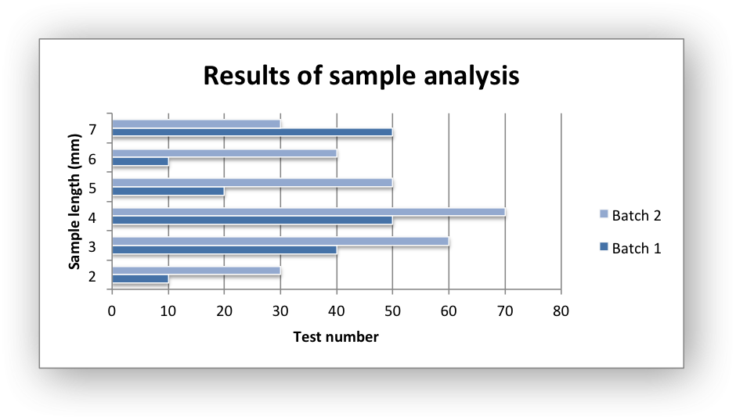

Figure 1. Font: Times New Roman, Size: 12 pt; Alignment: Center  
Source: Own Elaboration / Adapted by (Author, year) / Created by (Author, year)

**Equations**: Number equations consecutively. Be sure that the symbols in your equation have been defined before or immediately following the equation.

$α + β=γ$

  

# Conclusion/заключение

Summarize the results of the research/paper and write the conclusion with a few sentences here.

# References/изполвана литература

1. BRADBURY, I., BOYLE, J. and MORSE, A. (2002) *Scientific Principle for Physical Geographers*. Harlow: Prentice Hall.
2. CAMPBELL, N. A et.al. (2008) *Biology*. 8th Ed. London: Pearson.
3. KENNERLEY, M. and NEELY, A. (2003) Measuring performance in a changing business environment*. International Journal of Operations and Production Management*. 23 (2). pp. 213-229.
4. MITCHELL, J., A. and Thomson, M. (2017) *A guide to citation*. 3rd Ed. London: London Publishing.
5. MOULLIN, M. (2004) Eight essentials of performance management. *International Journal of Health Care Quality Assurance*. [Online] 17 (3). pp. 110-112. Available from: http://www.emeraldinsight.com/ [Accessed 2/03/2019].
6. NEVILLE, C. (2010) *The Complete Guide to Referencing and Avoiding Plagiarism*. 2nd Ed. Maidenhead: Open University Press.

Всички заглавия на кирилица трябва да се ТРАНСЛИТЕРИРАТ на латиница. Може да използвате: <https://2cyr.com> Пример: Petrov, G. (2017) Predstavyane na ikonomicheskite nauki v razlichni klasifikatsionni shemi. Izvestia Journal of the Union of Scientists - Varna. Economic Sciences Series. Varna: Union of Scientists - Varna. volume 6, issue 2, pp.234-242.